**LIBRARY MANAGEMNET SYSTEM**

**QUESTION:**

Draw a use case diagram for Library Management System is an automation system used to manage a library and the different resource management required in it like cataloguing of books, allowing check out and return of books, invoicing, user management, etc. The user can search for books details using few book properties (Book ID, Title, Author, and Publisher). Searching should return details about all the book copies that match the search query.

**AIM:**

To develop a Use Case Diagram for a Library Management System that automates book cataloging, user management, book checkout/return, invoicing, and search functionalities.

**PROCEDURE:**

1. Identify actors: Librarian and User.

2. Define use cases:

* Manage Books (Add, Update, Delete)
* Search Books
* Management system, update management system , check membership

3. Establish relationships between actors and use cases.

4. Draw the Use Case Diagram showing interactions.

**DIAGRAM:**

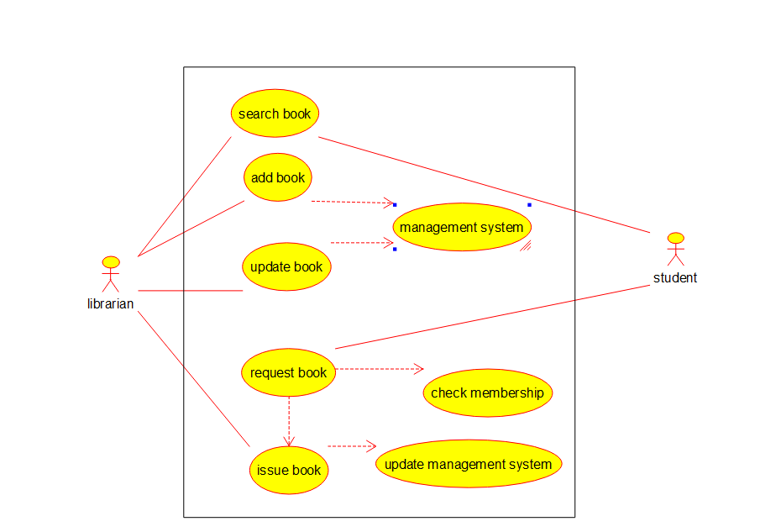

**RESULT:**

A Use Case Diagram for the Library Management System was successfully created.